Black Box Testing is the method that does not consider the internal structure, design, and product implementation to be tested.

In other words, the tester does not know its internal functioning. The Black Box only evaluates the external behavior of the system. The inputs received by the system and the outputs or responses it produces are tested.

Black-box testing, also called functional testing or behavioral testing

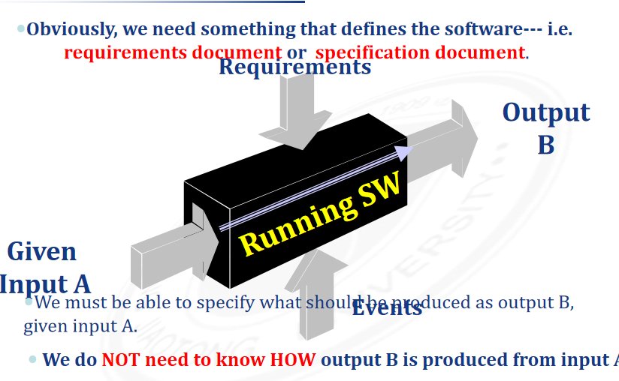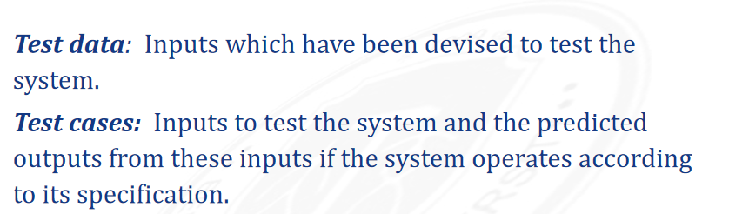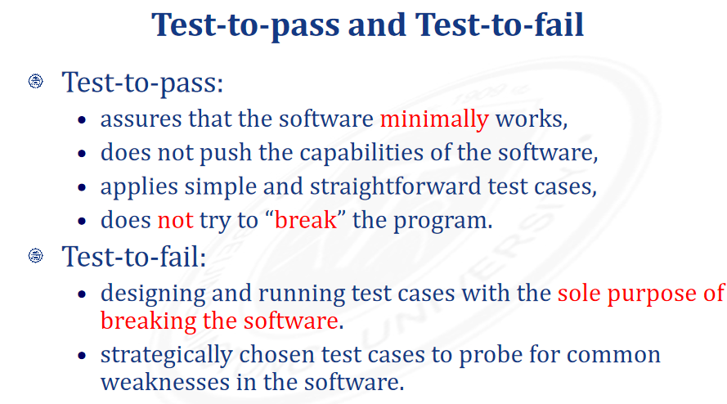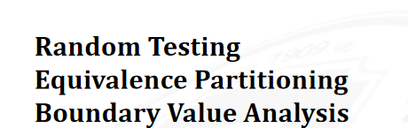

随机测试：

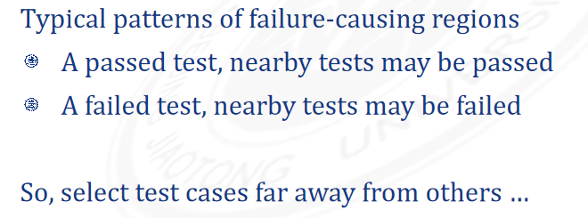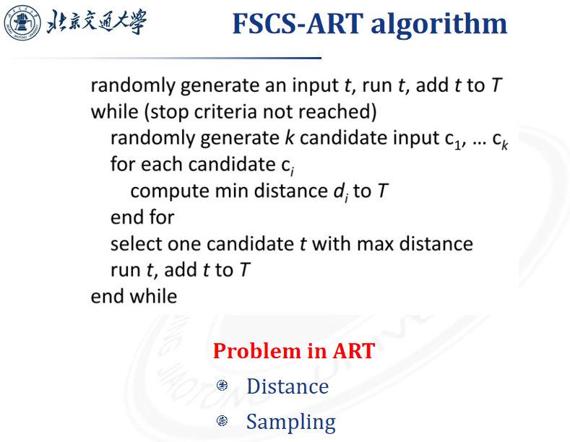每次先选几个用例,再从几个用例里选个与先前执行的测试距离最大的,重复上述步骤

